UK Online Retail Analysis (B2B Wholesale Case Study)
Prepared by: Wayne Chan
Date: February 2026
Tools Used:
- Python (Pandas, Matplotlib)
- Jupyter Notebook
- Git & GitHub
- Markdown Documentation

Executive Summary
This report analyzes a two-year UK wholesale retail transaction dataset (~1 million records) to evaluate revenue structure, seasonality, and return behavior.
Key findings show:
- Sales exhibit strong recurring seasonality, peaking between August and November.
- The November peak is primarily driven by increased order volume.
- Revenue follows a Pareto structure: the top 20% of customers contribute ~77% of total revenue.
- Return rates remain stable for most customers (median 1.45%), with extreme cases driven by wholesale order reversals rather than product defects.
The analysis suggests that profitability is primarily influenced by wholesale customer behavior rather than product-level quality issues.

📊 Page 2 — Core Findings
1️⃣ Sales Seasonality
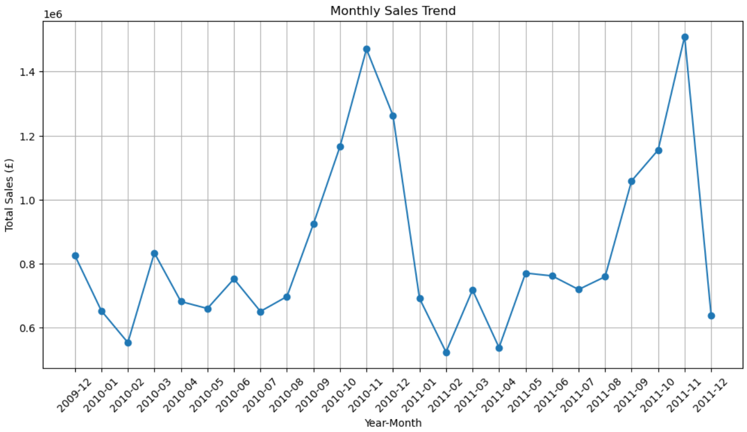
Revenue increases steadily from August to November across both years, indicating structural seasonal demand rather than a one-year anomaly.
November’s peak is volume-driven, while December shows higher average order value but lower order counts.

2️⃣ Revenue Concentration
- Top 20% of customers contribute ~77% of revenue.
- Top 10 customers contribute ~16%.
- No single product contributes more than 2% of total revenue.
This confirms a wholesale-driven structure with diversified product dependency but concentrated customer revenue.

3️⃣ Return Analysis
- Monthly return rates remain between 3–8%.
- January 2011 spike (~19%) likely reflects post-holiday returns.
- Median customer return rate: 1.45%.
- 75% of customers below 3%.
High return rates are concentrated among a few wholesale accounts due to bulk order reversals.

📌 Business Implications
- Revenue risk is concentrated among key wholesale accounts.
- Return spikes are operational rather than product-quality driven.
- Seasonal demand requires proactive inventory planning.

📌 Strategic Recommendations
- Introduce clearer wholesale return windows aligned with seasonal cycles.
- Strengthen monitoring of high-volume accounts.
- Implement loyalty or volume-based incentive programs to stabilize purchasing behavior.

